- Name of Use Case
Name of the Use Case | Remote Healthcare monitoring
Version No. | V0.1
Submission Date | 16/12/17
Team Members (with student ids) | Andres Muñoz s251735, Daniel Di Vita s251811, Juan Camilo Leon s251525, Miguel García S250554
- Scope and Objectives of Function
Scope and Objectives of Use Case
Scope | The proposed IoT platform aims at providing services of remote healthcare monitoring for elderly people that live in a nursing home.
Objective(s) | Provide real time information to the caretakers about the patient conditions to facilitate their healthcare.  Notify to the caretakers the emergency and warning alerts, related with the conditions of the patients.
Domain(s) | Telemedicine, eHealth, Healthcare.
Stakeholder(s) | Nursing homes, elderly people, caretakers.
Short description | The proposed IoT platform aims to bring information to the caretakers about the localization, heart rate and number of steps, and provides emergency and warnings alerts like fall detection and high heart rate of each patient of the nursing home. It allows the continuous monitoring of each patient and fast emergency reaction. Also, allows to the caretaker send information to the patient like notifications of walking time or taking the pills. This proposal will be reached through a wearable device for each patient, a web platform, and a mobile application for the caretakers that are connected using the internet.  Summarizing, the main features it offers are:  - Remote monitoring of the localization, walking and heart rate.  - Remote fall detection.  - Emergency Alerts.  - Web platform to visualize the data of all the patients.  - Mobile application for the caretakers that provides the data of a particular group of patients.

- Diagram of Use Case

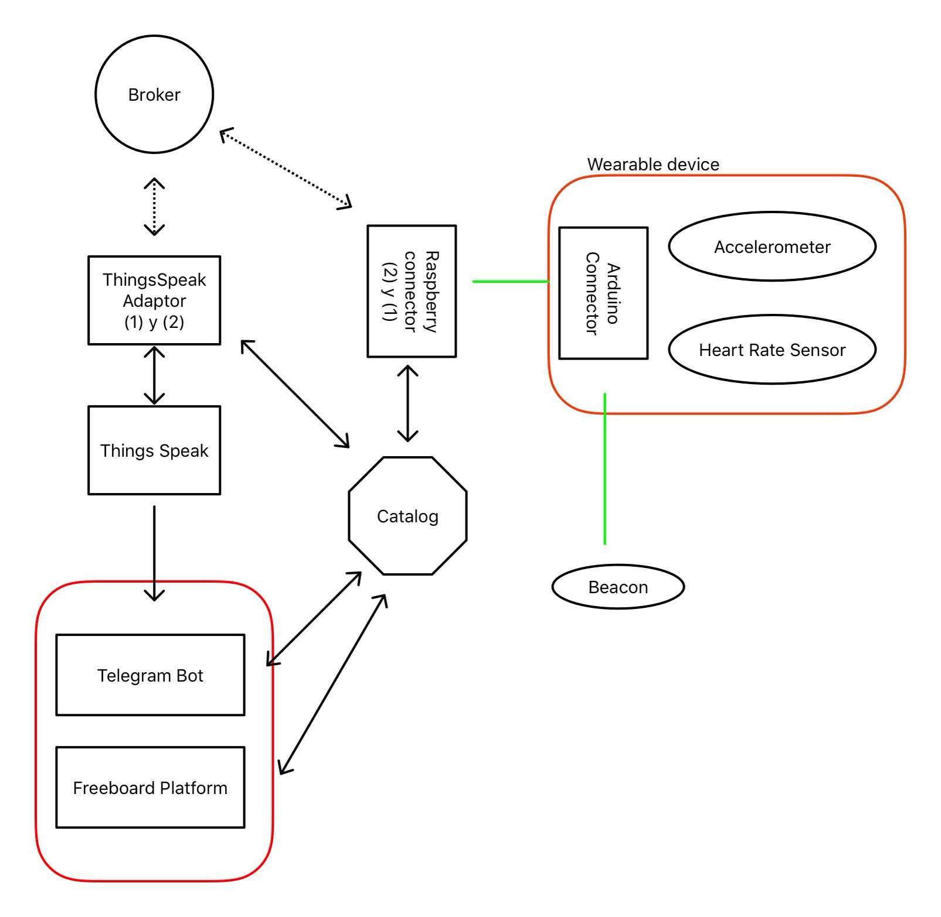
Wirreless comunication
RestFull comunication
MQTT communication
- Complete description of the system
The proposed IoT platform for Remote Healthcare monitoring exploits the two protocol communication paradigms:
- Publish/Subscribe based on MQTT protocol.
- Request/Response based on REST Web Services.

In this context, # actors have been identified and introduced in the following:
- The Message Broker provides an asynchronous communication based on the publish/subscribe
approach, using the MQTT protocol, between the Rapsberry Pi and the Thinkspeak adapter (Both subscriber and publisher).

- The Catalog works as a catalog for all the actors in the system. It provides information about the patients, the caretakers, and the end-points (i.e. REST Web Services and MQTT topics) of all the devices1, resources2 and services3.

- The Raspberry Pi Connector is an implementation of the Device Connector that integrates into the
platform raspberry pi boards. Each raspberry is wireless connected to the Arduino to provide patient’s information about their conditions. It works as an MQTT publisher sending information on patient data, and as an MQTT subscriber to receive actuation commands from the Thingkspeak IoT platform.

- The Arduino Pi Connector is an implementation that integrates into the platform Arduino boards. Each Arduino is equipped with one accelerometer, one heart rate sensor and a Bluetooth adaptor that receives information from the beacon sensor, and send the information to the raspberry through serial communication.

- The Thinkspeak Adaptor is an MQTT subscriber that receives patient data and upload them on Thinkspeak through REST Web Services. Also works as an MQTT publisher sending the notifications to the raspberry, received from Thinkspeak through REST Web Services.

- Thinkspeak is a third-party software that provides REST Web Services.

- Freeboad is a dashboard to retrieve data from IoT devices and visualize them exploiting the REST
Web Services provided by Raspberry Pi and Arduino Connectors. It also exploits the Thinkspeak
Web Services to import plots about patient data, location and alerts and warning.

- Telegram Bot is a service to integrate the proposed infrastructure into Telegram platform.
It retrieves alerts from IoT devices exploiting the REST Web Services provided by Raspberry Pi.
- Desired Hardware
Device Name | Quantity | Needed for…
Heart rate monitor sensor (ECG) | 1 | Monitoring heart rate
Accelerometer | 1 | Receive information about the patient movement
Estimote location beacon | 1 | Get data about the localization
Arduino nano | 1 | Communication between sensors

